PROJECT REPORT

1. **INTRODUCTION**
   1. **OVERVIEW**

A Brief description about the project

The project in the zoho books for Urban Aura Interiors involves the creation of financial statement, which includes income statement, balance sheet and cash flow statement. These statements are essential to assess the financial health of the company

* 1. **PURPOSE**

Zoho books is a project management software that helps you to track and manage work of our related Urban aura interiors.some highlighting features of zoho project.

1. **PROBLEM DEFINITION & DESIGN THINKING**
   1. **Empathy map**

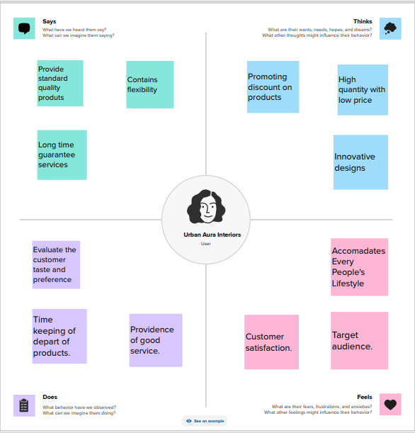

* 1. **Ideation & Brain storming Map**

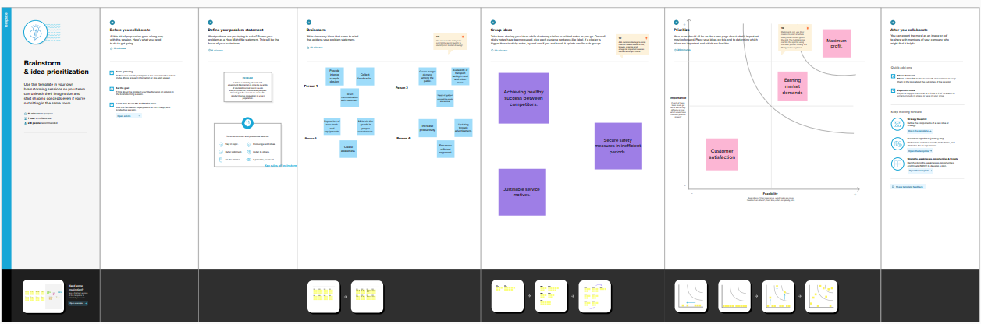

**3 RESULTS**

Final findings ( Output) of the project along with screenshots.

**PROFIT& LOSS BALANCE SHEET**

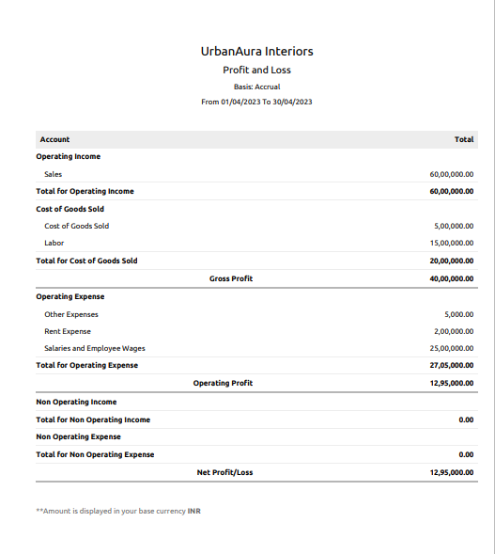 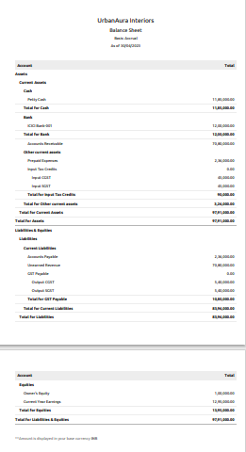

**4. ADVANTAGES & DISADVANTAGES**

**4.1 ADVANTAGES**

* Report generation.
* Inventory management.
* Project management & Timesheet.

**4.2 DISADVANTAGES**

* Accounts payable limitation.
* No Payroll services

**5. APPLICATION**

The areas where this solution can be applied

* Integration with payment gateways.
* Time tracking

**6. CONCLUSION**

* Zoho books is summarise for project work on financial statement result to show as a overview of show the URBANAURA INTERIORS report development and to improve the company’s profit .

**7. FUTURE SCOPE**

* Improvement coding features.
* Processing account payable.
* To improve awareness of software.

